- Create one Declarative pipeline job
Pre Requisite done.

# 1. Clone the original repo directly
git clone https://github.com/betawins/sabear_simplecutomerapp.git
cd sabear_simplecutomerapp

# 2. Connect to your GitHub repo
Go to GitHub → Create a new empty repository (without README).
Example: https://github.com/imrankhanmohammad257/sabear_simplecutomerapp.git
Add it as remote

git remote add origin https://github.com/imrankhanmohammad257/sabear_simplecutomerapp.git

# 3. Push all branches from original repo
Option 1
git checkout feature-1.1
git push origin feature-1.1
Option 2
git push origin 'refs/remotes/origin/*:refs/heads/*'

—-------------------------------------------------------- OR ---------------------------------------

1. Fork the required git hub repo from another github account.
# 1. Clone your fork (your GitHub repo)
git clone https://github.com/imrankhanmohammad257/sabear_simplecutomerapp.git
cd sabear_simplecutomerapp

# 2. Add the original repo as another remote
git remote add upstream https://github.com/betawins/sabear_simplecutomerapp.git

# 3. Fetch all branches from original repo
git fetch upstream

# 4. Checkout the feature branch you want
git checkout -b feature-1.1 upstream/feature-1.1

# 5. Push it to your repo (fork)
git push origin feature-1.1

—-----------------------------------------------------------------------------------------------------

Jenkins CI/CD Pipeline for Simple Customer App

1. Job Overview
The Simple Customer App Jenkins job automates the following tasks:
- Checkout code from GitHub repository
- Build the project using Maven
- Run SonarQube code analysis
- Deploy the WAR file to Nexus repository
- Deploy the WAR file to Tomcat server
- Send Slack notifications for build status

2. Prerequisites
Before creating the Jenkins job, ensure the following are set up:
- Jenkins server with required plugins:
  - Git Plugin
  - Maven Integration Plugin
  - SonarQube Scanner Plugin
  - Slack Notification Plugin
- Maven installed on Jenkins (e.g., Maven 3.8.4)
- SonarQube server configured in Jenkins
- Nexus repository with admin credentials
- Tomcat server installed and running
- Jenkins credentials created for:
  - Nexus (nexus-creds)
  - Tomcat (tomcat-credentials)
  - Slack (slack_notification)

3. GitHub Repository
- Repository URL:
https://github.com/imrankhanmohammad257/sabear_simplecutomerapp.git
- Branch: feature-1.1
The repository contains the SimpleCustomerApp project, structured as a Maven WAR project.

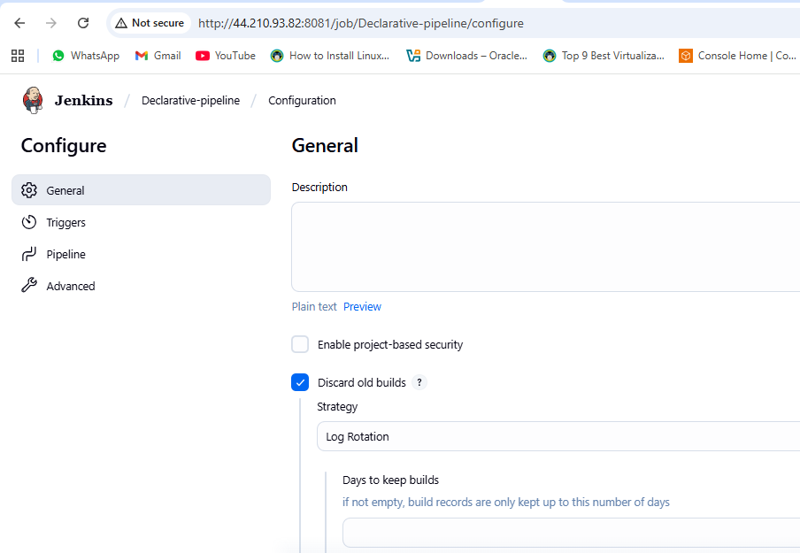
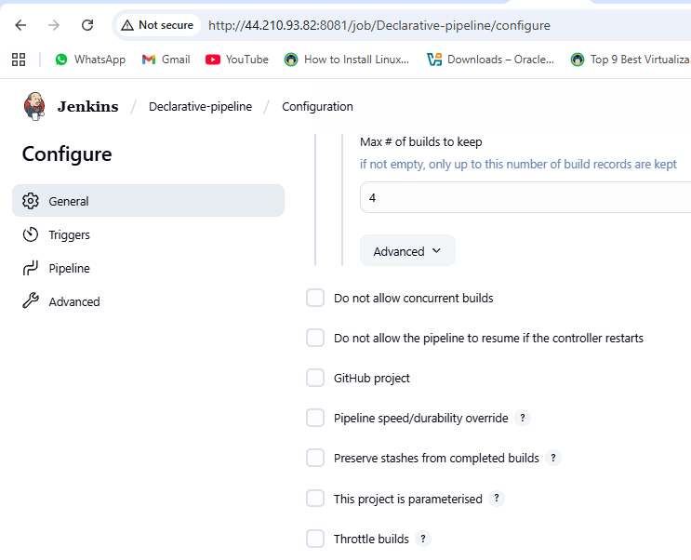
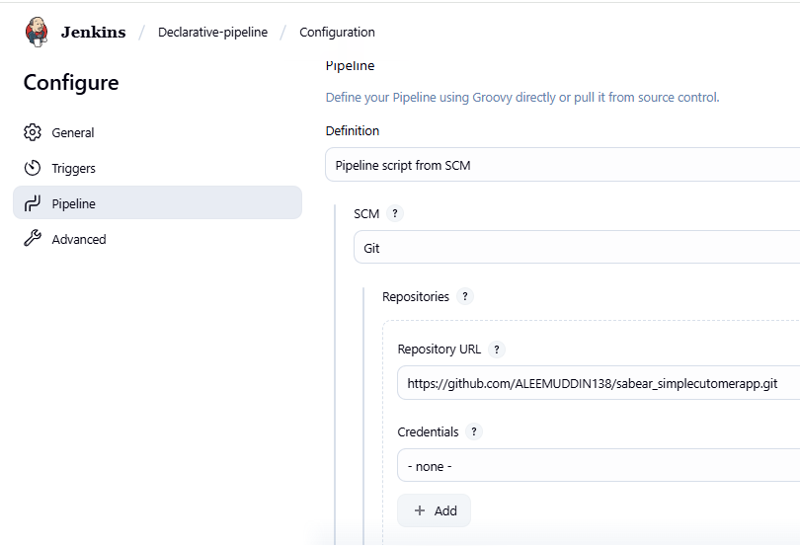
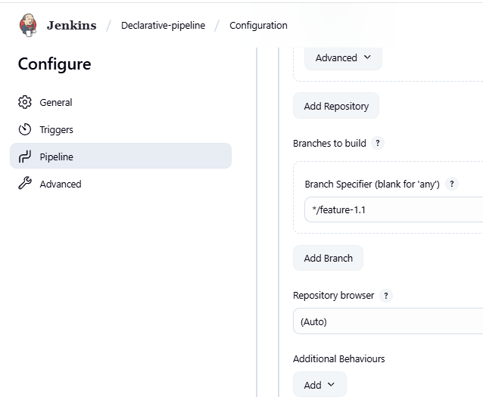
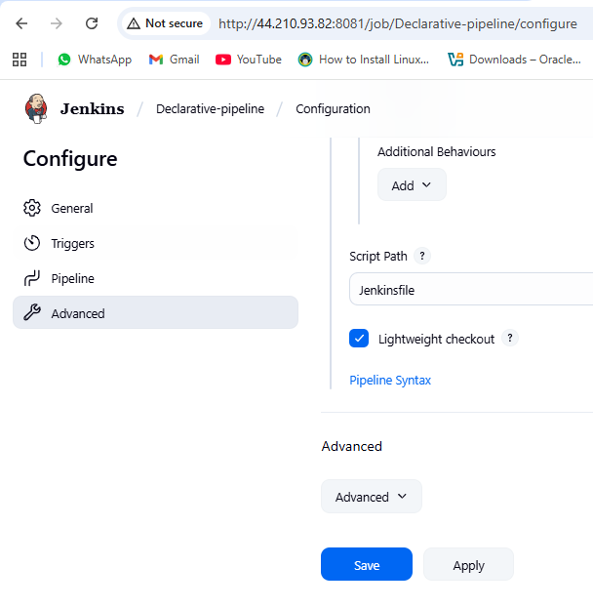

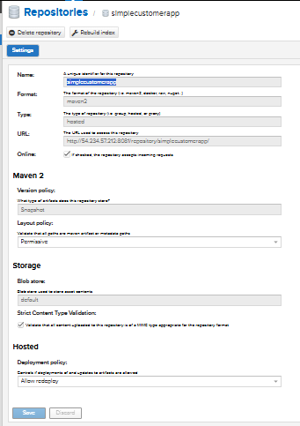
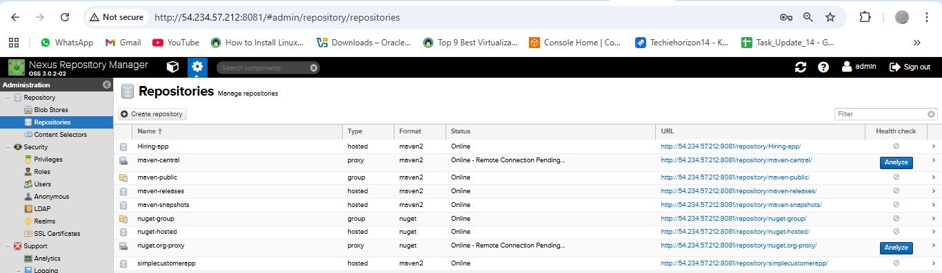
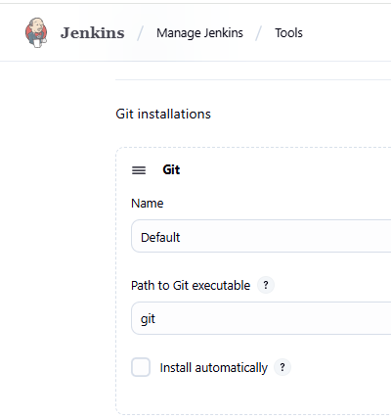
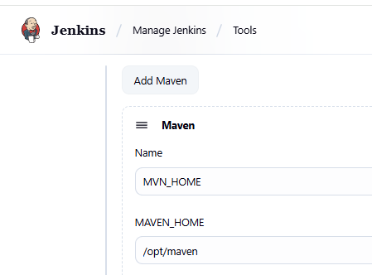
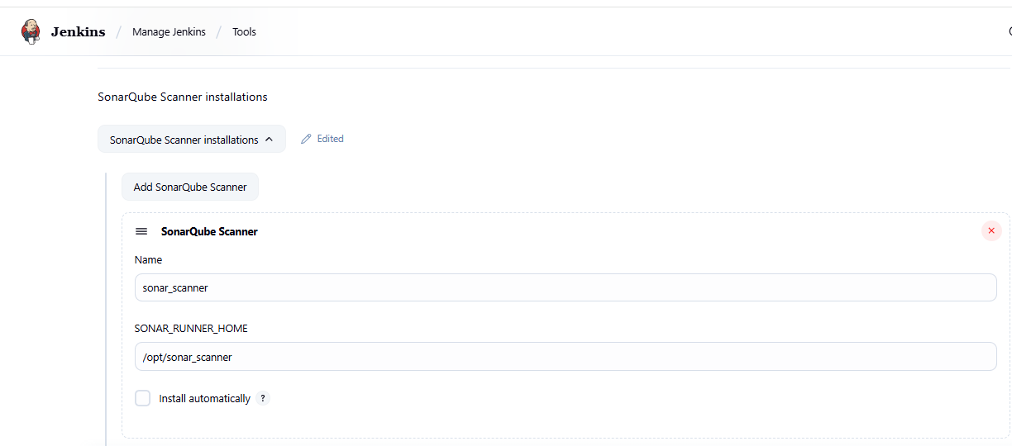
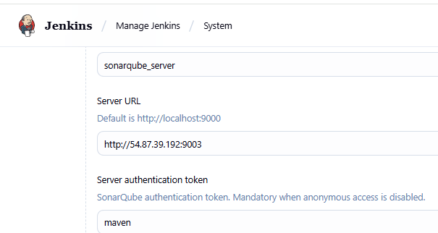
pipeline {
agent any
tools {
maven 'MVN_HOME'
}
environment {
NEXUS_VERSION = "nexus3"
NEXUS_PROTOCOL = "http"
NEXUS_URL = "54.234.57.212:8081"
NEXUS_REPOSITORY = "simplecustomerapp"
NEXUS_CREDENTIAL_ID = "Nexus-server"
SCANNER_HOME = tool 'sonar_scanner'
// Slack details (already configured in Jenkins → Configure System → Slack)
SLACK_CHANNEL = "#jenkins-integration"
}
stages {
stage("clone code") {
steps {
git 'https://github.com/ALEEMUDDIN138/sabear_simplecutomerapp.git'
}
}
stage('Build') {
steps {
sh 'mvn -Dmaven.test.failure.ignore=true clean install'
}
}

stage("SonarCloud") {
steps {
withSonarQubeEnv('sonarqube_server') {
sh '''$SCANNER_HOME/bin/sonar-scanner \
-Dsonar.projectKey=Ncodeit \
-Dsonar.projectName=Ncodeit \
-Dsonar.projectVersion=2.0 \
-Dsonar.sources=/var/lib/jenkins/workspace/$JOB_NAME/src/ \
-Dsonar.binaries=target/classes/com/visualpathit/account/controller/ \
-Dsonar.junit.reportsPath=target/surefire-reports \
-Dsonar.jacoco.reportPath=target/jacoco.exec \
-Dsonar.java.binaries=src/com/room/sample '''
}
}
}
stage("publish to nexus") {
steps {
script {
def pom = readMavenPom file: "pom.xml"
def filesByGlob = findFiles(glob: "target/*.${pom.packaging}")
echo "${filesByGlob[0].name} ${filesByGlob[0].path}"
def artifactPath = filesByGlob[0].path
def artifactExists = fileExists artifactPath

if (artifactExists) {
nexusArtifactUploader(
nexusVersion: NEXUS_VERSION,
protocol: NEXUS_PROTOCOL,
nexusUrl: NEXUS_URL,
groupId: pom.groupId,
version: pom.version,
repository: NEXUS_REPOSITORY,
credentialsId: NEXUS_CREDENTIAL_ID,
artifacts: [
[artifactId: pom.artifactId, classifier: '', file: artifactPath, type: pom.packaging],
[artifactId: pom.artifactId, classifier: '', file: "pom.xml", type: "pom"]
]
)
} else {
error "*** File: ${artifactPath}, could not be found"
}
}
}
}

// stage("Deploy to Tomcat") {
// steps {
// withCredentials([usernamePassword(credentialsId: '6032f458-5f14-4354-9500-645db052e2b5', usernameVariable: 'TOMCAT_USER', passwordVariable: 'TOMCAT_PASS')]) {
// script {
// // Find the WAR file built by Maven
// def warFile = sh(script: "ls target/*.war | head -n 1", returnStdout: true).trim()
// def warName = sh(script: "basename ${warFile} .war | tr '[:upper:]' '[:lower:]'", returnStdout: true).trim()
// echo "Deploying ${warFile} to Tomcat at context path /${warName}..."
// sh """
// curl -u $TOMCAT_USER:$TOMCAT_PASS \\
// -T ${warFile} \\
// "http://52.207.241.86:8080/manager/text/deploy?path=/${warName}&update=true"
stage("Deploy to Tomcat") {
steps {
withCredentials([usernamePassword(credentialsId: '6032f458-5f14-4354-9500-645db052e2b5', usernameVariable: 'TOMCAT_USER', passwordVariable: 'TOMCAT_PASS')]) {
script {
// Find the WAR file built by Maven
def warFile = sh(script: "ls target/*.war | head -n 1", returnStdout: true).trim()
echo "Deploying ${warFile} to Tomcat at context path /simplecustomerapp ..."
sh """
curl -u $TOMCAT_USER:$TOMCAT_PASS \
-T ${warFile} \
"http://52.207.241.86:8080/manager/text/deploy?path=/simplecustomerapp&update=true"
"""
}
}
}
}
stage("Slack Notification") {
steps {
slackSend(
channel: "${SLACK_CHANNEL}",
color: "#36A64F",
message: "Declarative pipeline for *Simple Customer App* has been successfully deployed in Tomcat :white_check_mark: by ALEEM for Job: ${env.JOB_NAME} [${env.BUILD_NUMBER}]"
)
}
}
}
}
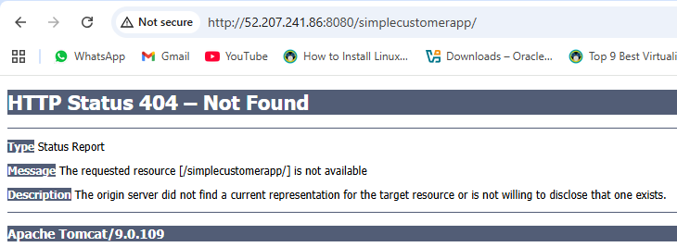
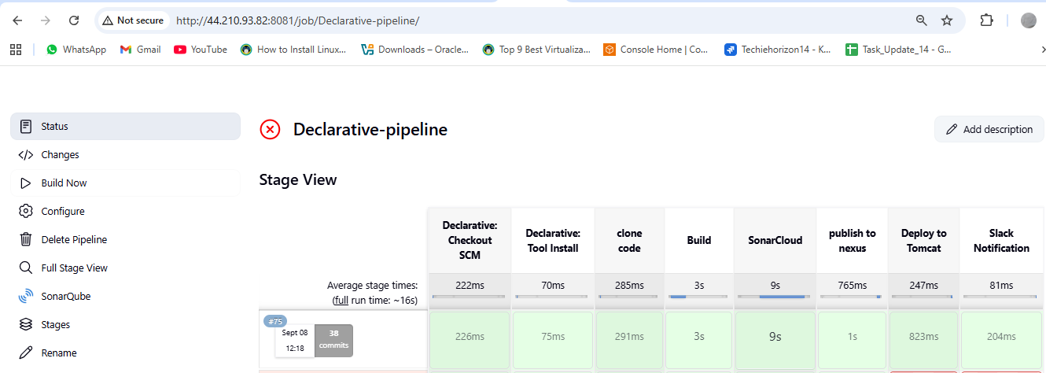
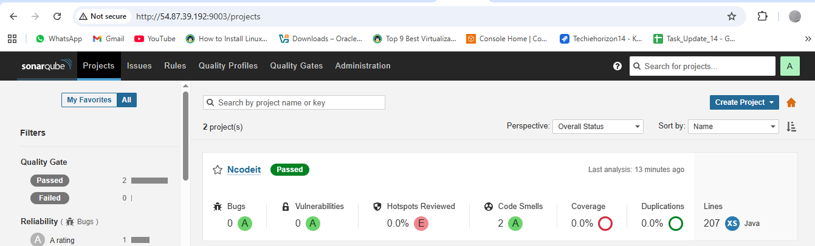
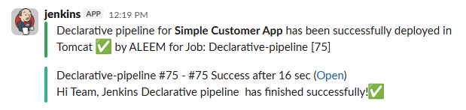
- Create one scripted pipeline job

1) Prereqs you set up
- Jenkins controller with plugins: Pipeline, Git, Maven Integration, SonarQube Scanner, Credentials, Slack.
- Tools in Jenkins → Global Tool Config
  - JDK (e.g., Java 17)
  - Maven named Maven-3.8.4
- Servers
  - SonarQube reachable and configured in Jenkins as server name SonarQube.
  - Nexus (two repos: maven-snapshots and releases).
  - Tomcat with manager-script user enabled.
- Credentials in Jenkins → Credentials
  - nexus-creds (username/password)
  - tomcat-credentials (username/password)
  - slack_notification (Slack token for your workspace)
- Maven settings on the Jenkins box: /var/lib/jenkins/.m2/settings.xml with matching <server> IDs for your POM:
<distributionManagement>
<repository>
<id>releases</id>
<url>http://54.209.186.138:8081/repository/maven-releases/</url>
</repository>
<snapshotRepository>
<id>snapshots</id>
<url>http://54.209.186.138:8081/repository/maven-snapshots/</url>
</snapshotRepository>
</distributionManagement>

2) The Scripted Pipeline you ran
Repo & branch: https://github.com/imrankhanmohammad257/sabear_simplecutomerapp.git @ feature-1.1
node {
stage('Git Clone') {
git branch: 'feature-1.1',
url: 'https://github.com/imrankhanmohammad257/sabear_simplecutomerapp.git'
}

stage('SonarQube Analysis') {
withSonarQubeEnv('SonarQube') {
sh 'mvn sonar:sonar'
}
}

stage('Maven Compilation') {
def mvnHome = tool name: 'Maven-3.8.4', type: 'maven'
sh "${mvnHome}/bin/mvn clean compile"
}

stage('Deploy to Nexus') {
withCredentials([usernamePassword(credentialsId: 'nexus-creds', usernameVariable: 'NEXUS_USER', passwordVariable: 'NEXUS_PASS')]) {
sh '''
mvn clean deploy -DskipTests --settings /var/lib/jenkins/.m2/settings.xml
'''
}
}

stage('Slack Notification') {
slackSend(
channel: '#jenkins-integration',
color: 'good',
message: "Jenkins Scripted Pipeline job for *sabear_simplecutomerapp (feature-1.1)* finished successfully! ✅"
)
}

stage('Deploy to Tomcat') {
withCredentials([usernamePassword(credentialsId: 'tomcat-credentials', usernameVariable: 'TOMCAT_USER', passwordVariable: 'TOMCAT_PASS')]) {
sh '''
set -e

WAR_FILE=$(ls target/*.war | head -n 1)

echo "WAR file to deploy: $WAR_FILE"

echo "Undeploying old app..."
curl -s -o /dev/null -w "%{http_code}\\n" -u $TOMCAT_USER:$TOMCAT_PASS \
"http://54.87.222.232:8080/manager/text/undeploy?path=/customerapp"

echo "Deploying new WAR..."
curl -s -o /dev/null -w "%{http_code}\\n" -u $TOMCAT_USER:$TOMCAT_PASS \
-T "$WAR_FILE" \
"http://54.87.222.232:8080/manager/text/deploy?path=/customerapp&update=true"

echo "Deployment completed."
'''
}
}
}

3) What happened in each stage (what you observed)
- Git Clone
Jenkins pulled feature-1.1 into the job workspace.
- Maven Build/Package
  - Executed mvn clean package -DskipTests.
  - Produced target/SimpleCustomerApp-1.0-SNAPSHOT.war.
- SonarQube Analysis
  - Ran mvn sonar:sonar under withSonarQubeEnv('SonarQube').
  - SonarQube accepted the report (dashboard link showed analysis OK).
- Nexus Deploy
  - Attempted mvn deploy.
  - You initially hit issues:
    - 401 Unauthorized → fixed by ensuring settings.xml <servers> IDs matched your POM’s <distributionManagement> IDs and by using Jenkins credentials.
    - Connection timed out → pointed Maven to the correct Nexus IP/port.
  - After fixes, artifacts upload to snapshots repo (because version is 1.0-SNAPSHOT).
- Deploy on Tomcat
  - You added an undeploy first call to avoid stale app:
.../manager/text/undeploy?path=/customerapp
  - Then deployed the freshly built WAR to context /customerapp with update=true.
  - Tomcat logs (tail -f /opt/tomcat/logs/catalina.out) confirmed (un)deploy events.
- Slack Notification
Sent status messages to #jenkins-integration using slack_notification token.
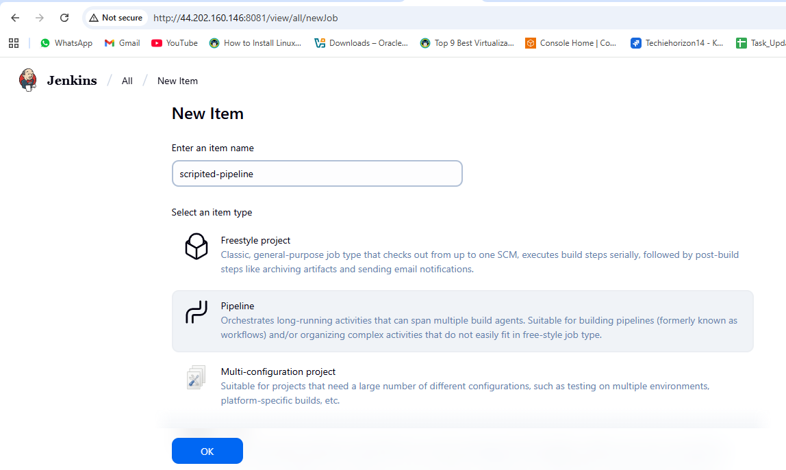
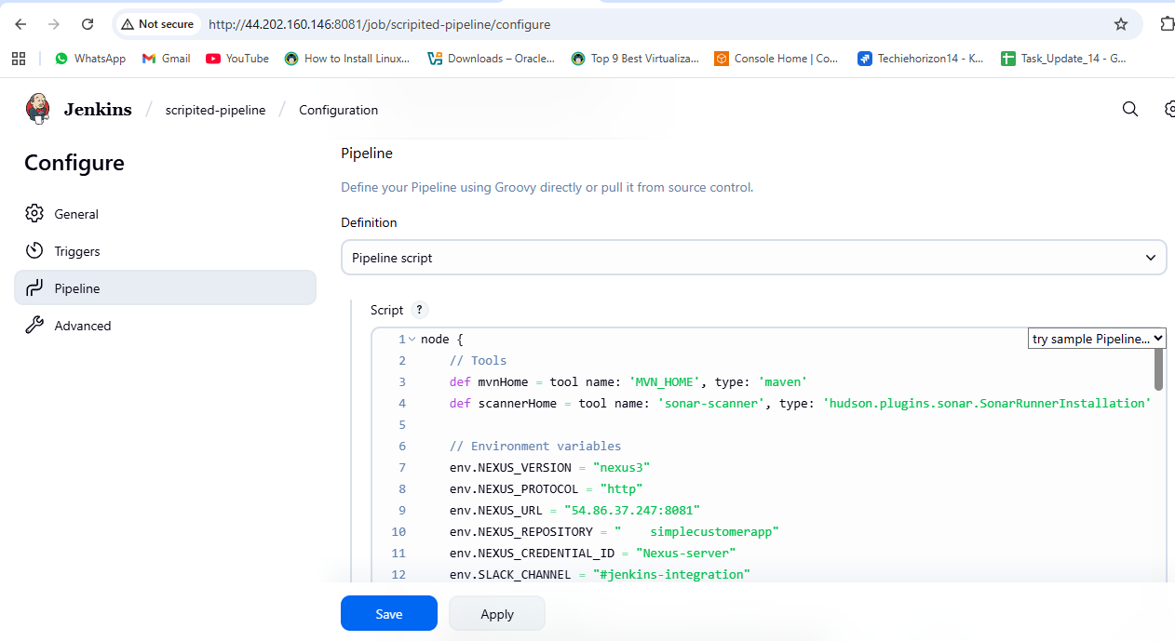
node {
// Tools
def mvnHome = tool name: 'MVN_HOME', type: 'maven'
def scannerHome = tool name: 'sonar_scanner', type: 'hudson.plugins.sonar.SonarRunnerInstallation'

// Environment variables
env.NEXUS_VERSION = "nexus3"
env.NEXUS_PROTOCOL = "http"
env.NEXUS_URL = "54.86.37.247:8081"
env.NEXUS_REPOSITORY = "simplecustomerapp"
env.NEXUS_CREDENTIAL_ID = "Nexus-server"
env.SLACK_CHANNEL = "#jenkins-integration"

stage("Clone Code") {
git 'https://github.com/ALEEMUDDIN138/sabear_simplecutomerapp.git'
}

stage("Build") {
sh "${mvnHome}/bin/mvn -Dmaven.test.failure.ignore=true clean install"
}

stage("SonarCloud") {
withSonarQubeEnv('sonarqube_server') {
sh """
${scannerHome}/bin/sonar-scanner \
-Dsonar.projectKey=Ncodeit \
-Dsonar.projectName=Ncodeit \
-Dsonar.projectVersion=2.0 \
-Dsonar.sources=${WORKSPACE}/src/ \
-Dsonar.binaries=target/classes/com/visualpathit/account/controller/ \
-Dsonar.junit.reportsPath=target/surefire-reports \
-Dsonar.jacoco.reportPath=target/jacoco.exec \
-Dsonar.java.binaries=src/com/room/sample
"""
}
}

stage("Publish to Nexus") {
script {
def pom = readMavenPom file: "pom.xml"
def filesByGlob = findFiles(glob: "target/*.${pom.packaging}")
echo "${filesByGlob[0].name} ${filesByGlob[0].path}"
def artifactPath = filesByGlob[0].path
def artifactExists = fileExists artifactPath
if (artifactExists) {
nexusArtifactUploader(
nexusVersion: env.NEXUS_VERSION,
protocol: env.NEXUS_PROTOCOL,
nexusUrl: env.NEXUS_URL,
groupId: pom.groupId,
version: pom.version,
repository: env.NEXUS_REPOSITORY,
credentialsId: env.NEXUS_CREDENTIAL_ID,
artifacts: [
[artifactId: pom.artifactId, classifier: '', file: artifactPath, type: pom.packaging],
[artifactId: pom.artifactId, classifier: '', file: "pom.xml", type: "pom"]
]
)
} else {
error "*** File: ${artifactPath}, could not be found"
}
}
}

stage("Deploy to Tomcat") {
withCredentials([usernamePassword(credentialsId: '6032f458-5f14-4354-9500-645db052e2b5', usernameVariable: 'TOMCAT_USER', passwordVariable: 'TOMCAT_PASS')]) {
script {
def warFile = sh(script: "ls target/*.war | head -n 1", returnStdout: true).trim()
echo "Deploying ${warFile} to Tomcat at context path /simplecustomerapp ..."
sh """
curl -u $TOMCAT_USER:$TOMCAT_PASS \
-T ${warFile} \
"http://3.84.151.154:8080/manager/text/deploy?path=/simplecustomerapp&update=true"
"""
}
}
}

stage("Slack Notification") {
slackSend(
channel: "${env.SLACK_CHANNEL}",
color: "#36A64F",
message: "Scripted pipeline for *Simple Customer App* has been successfully deployed in Tomcat :white_check_mark: by Aleem for Job: ${env.JOB_NAME} [${env.BUILD_NUMBER}]"
)
}
}
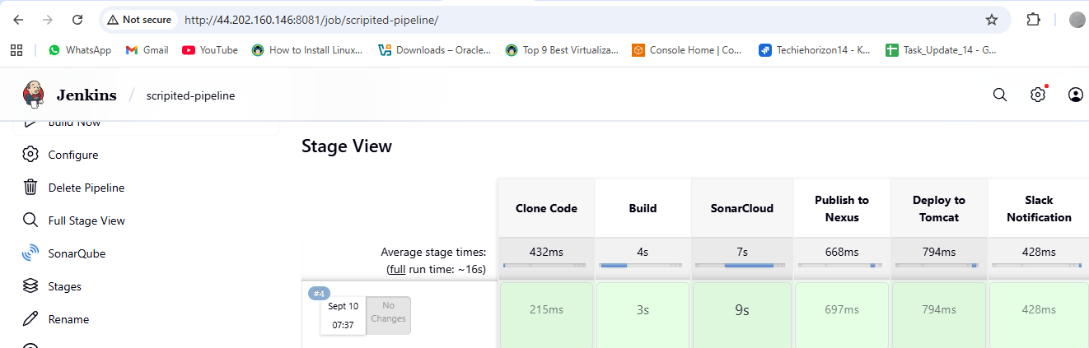
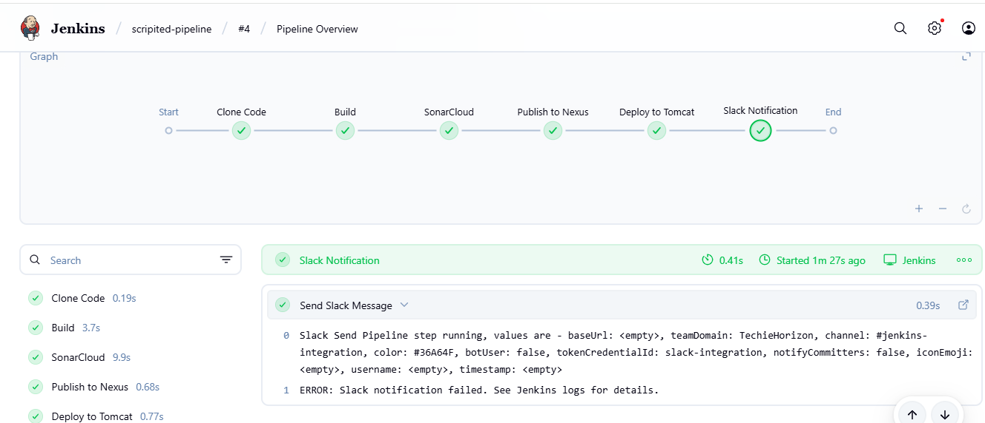
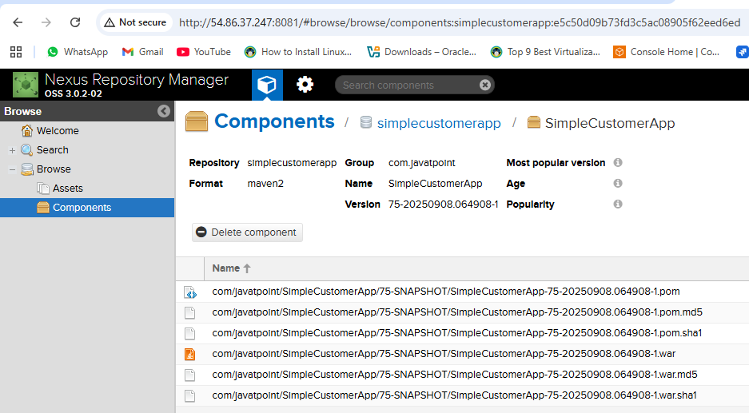
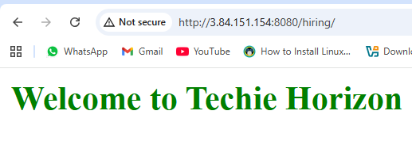

3) Create one multi stage pipeline job

1. Objective
Create a Jenkins multi-stage scripted pipeline that:
- Checks out code from GitHub.
- Builds the Maven project.
- Performs SonarQube code analysis.
- Deploys artifacts to Nexus repository.
- Deploys WAR file to Tomcat server.
- Sends Slack notification after successful deployment.

2. Prerequisites
- Jenkins EC2 instance with:
  - Java (JDK 17 recommended)
  - Maven (configured either via Jenkins tool or manually)
  - Jenkins user with proper permissions
- GitHub repository:
https://github.com/imrankhanmohammad257/hiring-app.git
- SonarQube server (e.g., http://54.90.169.53:9000) configured in Jenkins.
- Nexus repository (e.g., http://54.163.17.174:8081) with credentials in Jenkins.
- Tomcat server for deployment, with manager credentials.
- Slack webhook and channel for notifications (optional).
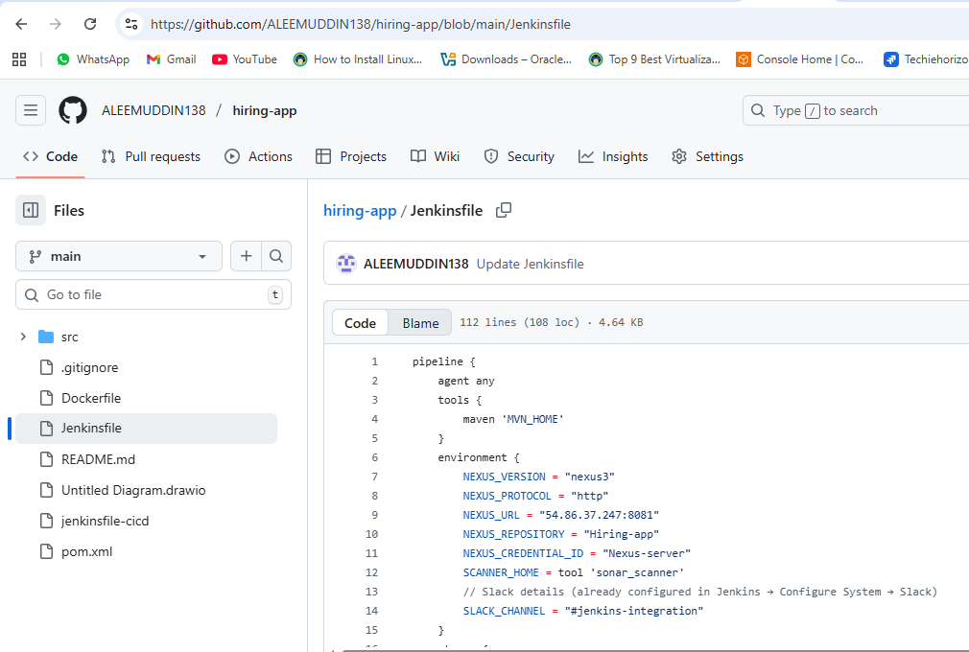
pipeline {
agent any
tools {
maven 'MVN_HOME'
}
environment {
NEXUS_VERSION = "nexus3"
NEXUS_PROTOCOL = "http"
NEXUS_URL = "54.86.37.247:8081"
NEXUS_REPOSITORY = "Hiring-app"
NEXUS_CREDENTIAL_ID = "Nexus-server"
SCANNER_HOME = tool 'sonar_scanner'
// Slack details (already configured in Jenkins → Configure System → Slack)
SLACK_CHANNEL = "#jenkins-integration"
}
stages {
stage("clone code") {
steps {
git branch: 'main', url: 'https://github.com/ALEEMUDDIN138/hiring-app.git'
}
}
stage('Build') {
steps {
sh 'mvn -Dmaven.test.failure.ignore=true clean install'
}
}

stage("SonarCloud") {
steps {
withSonarQubeEnv('sonarqube_server') {
sh '''$SCANNER_HOME/bin/sonar-scanner \
-Dsonar.projectKey=Ncodeit \
-Dsonar.projectName=Ncodeit \
-Dsonar.projectVersion=2.0 \
-Dsonar.sources=/var/lib/jenkins/workspace/$JOB_NAME/src/ \
-Dsonar.binaries=target/classes/com/visualpathit/account/controller/ \
-Dsonar.junit.reportsPath=target/surefire-reports \
-Dsonar.jacoco.reportPath=target/jacoco.exec \
-Dsonar.java.binaries=src/com/room/sample '''
}
}
}
stage("publish to nexus") {
steps {
script {
def pom = readMavenPom file: "pom.xml"
def filesByGlob = findFiles(glob: "target/*.${pom.packaging}")
echo "${filesByGlob[0].name} ${filesByGlob[0].path}"
def artifactPath = filesByGlob[0].path
def artifactExists = fileExists artifactPath

if (artifactExists) {
nexusArtifactUploader(
nexusVersion: NEXUS_VERSION,
protocol: NEXUS_PROTOCOL,
nexusUrl: NEXUS_URL,
groupId: pom.groupId,
version: pom.version,
repository: NEXUS_REPOSITORY,
credentialsId: NEXUS_CREDENTIAL_ID,
artifacts: [
[artifactId: pom.artifactId, classifier: '', file: artifactPath, type: pom.packaging],
[artifactId: pom.artifactId, classifier: '', file: "pom.xml", type: "pom"]
]
)
} else {
error "*** File: ${artifactPath}, could not be found"
}
}
}
}

// stage("Deploy to Tomcat") {
// steps {
// withCredentials([usernamePassword(credentialsId: '6032f458-5f14-4354-9500-645db052e2b5', usernameVariable: 'TOMCAT_USER', passwordVariable: 'TOMCAT_PASS')]) {
// script {
// // Find the WAR file built by Maven
// def warFile = sh(script: "ls target/*.war | head -n 1", returnStdout: true).trim()
// def warName = sh(script: "basename ${warFile} .war | tr '[:upper:]' '[:lower:]'", returnStdout: true).trim()
// echo "Deploying ${warFile} to Tomcat at context path /${warName}..."
// sh """
// curl -u $TOMCAT_USER:$TOMCAT_PASS \\
// -T ${warFile} \\
// "http://52.207.241.86:8080/manager/text/deploy?path=/${warName}&update=true"
stage("Deploy to Tomcat") {
steps {
withCredentials([usernamePassword(credentialsId: '6032f458-5f14-4354-9500-645db052e2b5', usernameVariable: 'TOMCAT_USER', passwordVariable: 'TOMCAT_PASS')]) {
script {
// Find the WAR file built by Maven
def warFile = sh(script: "ls target/*.war | head -n 1", returnStdout: true).trim()
echo "Deploying ${warFile} to Tomcat at context path /Hiring-app ..."
sh """
curl -u $TOMCAT_USER:$TOMCAT_PASS \
-T ${warFile} \
"http://3.84.151.154:8080/manager/text/deploy?path=/Hiring-app&update=true"
"""
}
}
}
}
stage("Slack Notification") {
steps {
slackSend(
channel: "${SLACK_CHANNEL}",
color: "#36A64F",
message: "Multistage pipeline for *Hiring-App* has been successfully deployed in Tomcat :white_check_mark: by ALEEM for Job: ${env.JOB_NAME} [${env.BUILD_NUMBER}]"
)
}
}
}
}
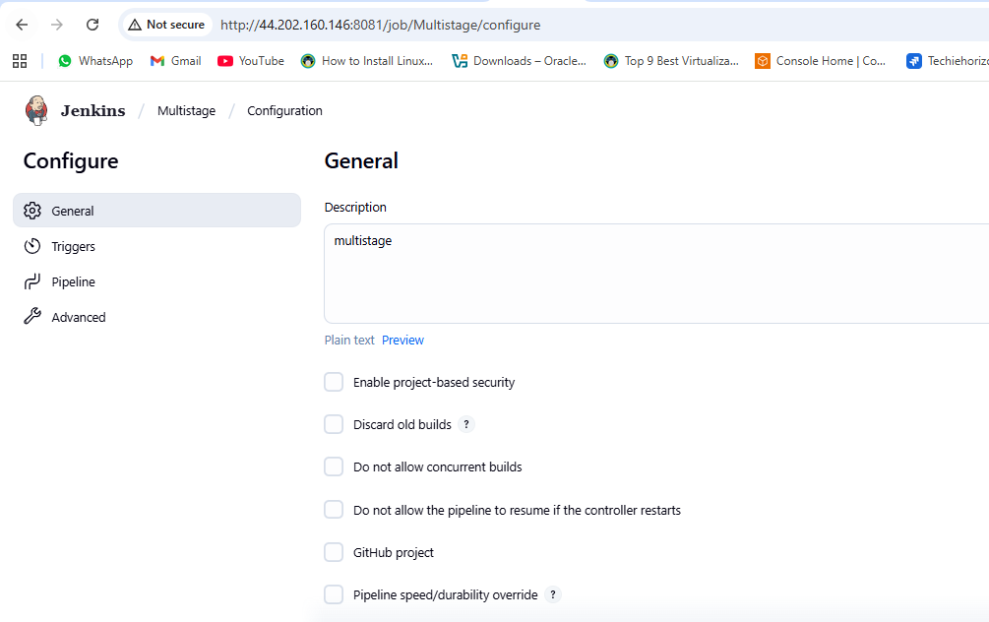
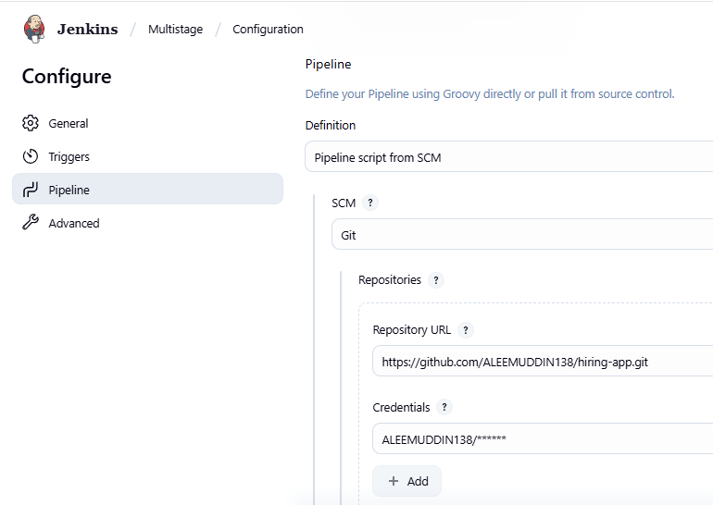
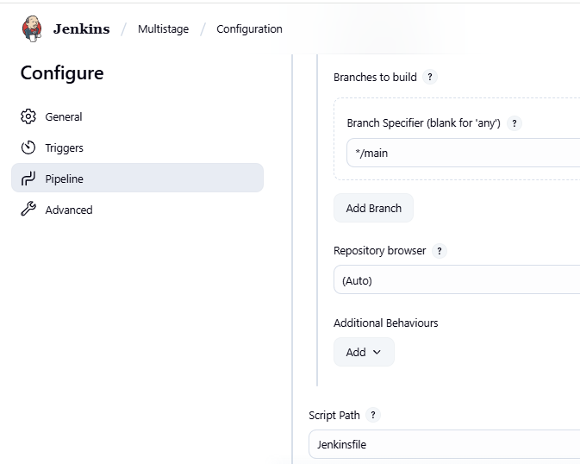
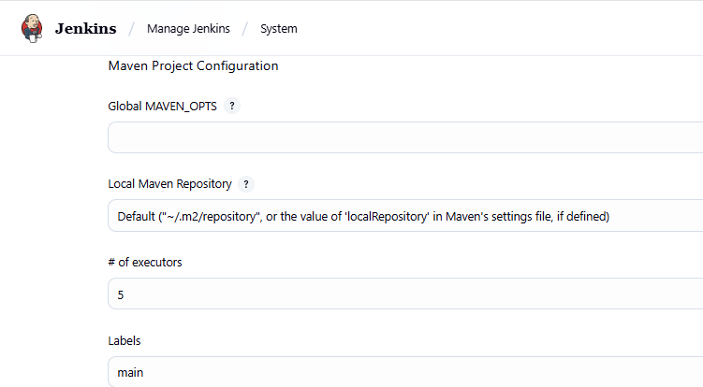

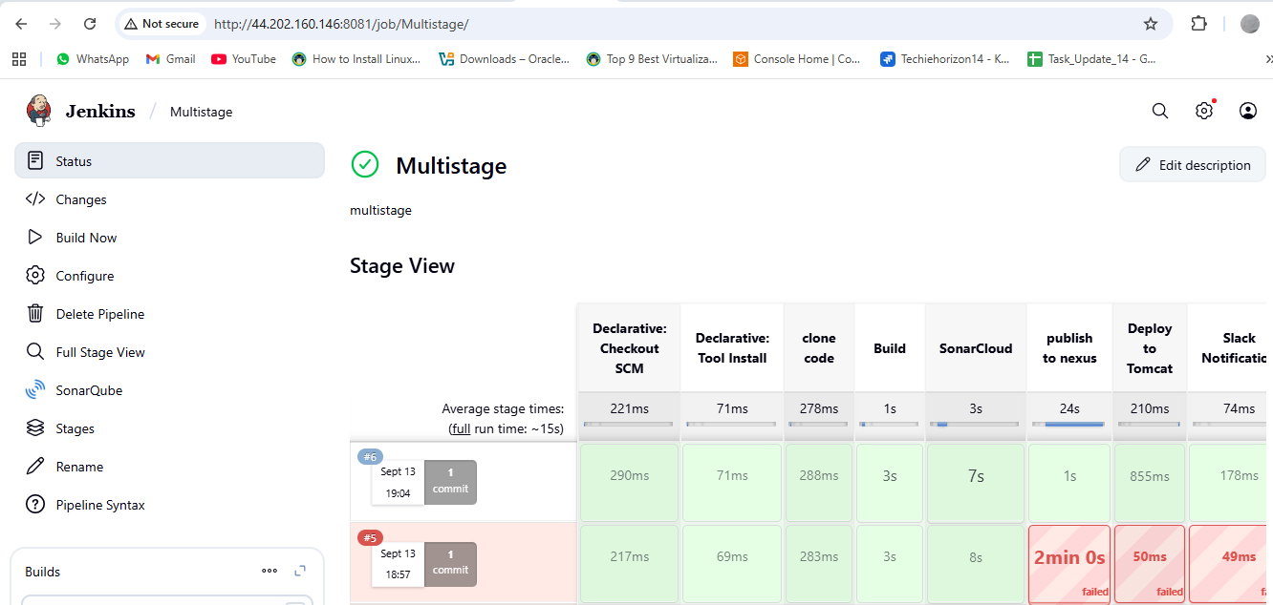
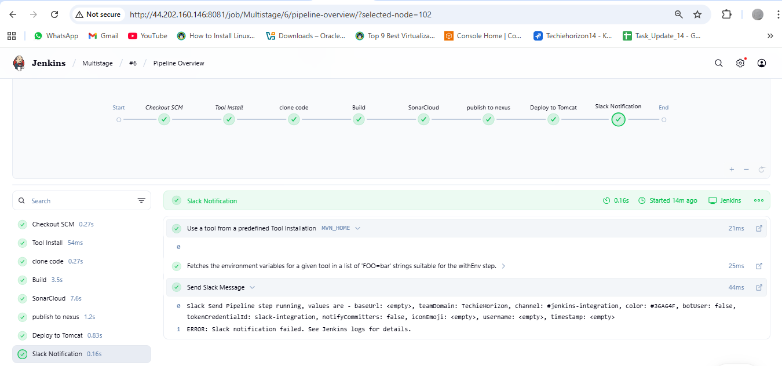
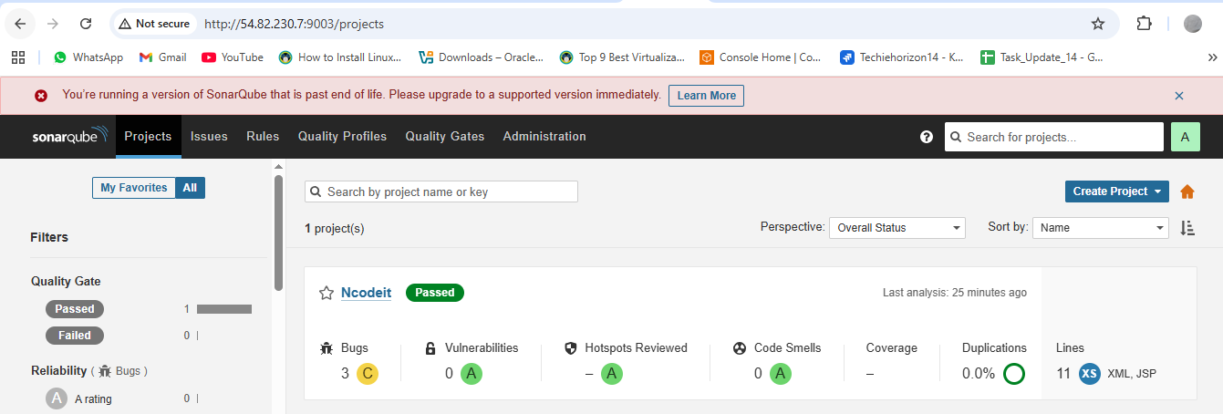
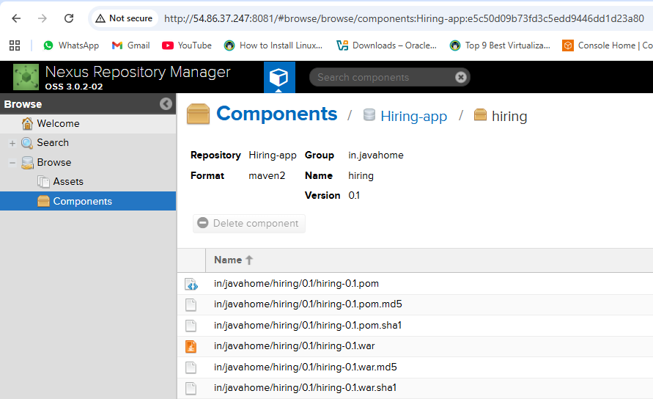
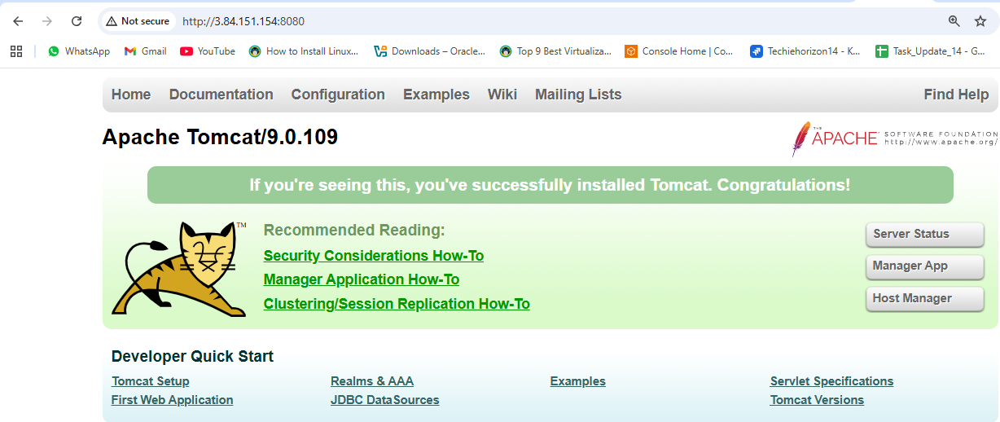
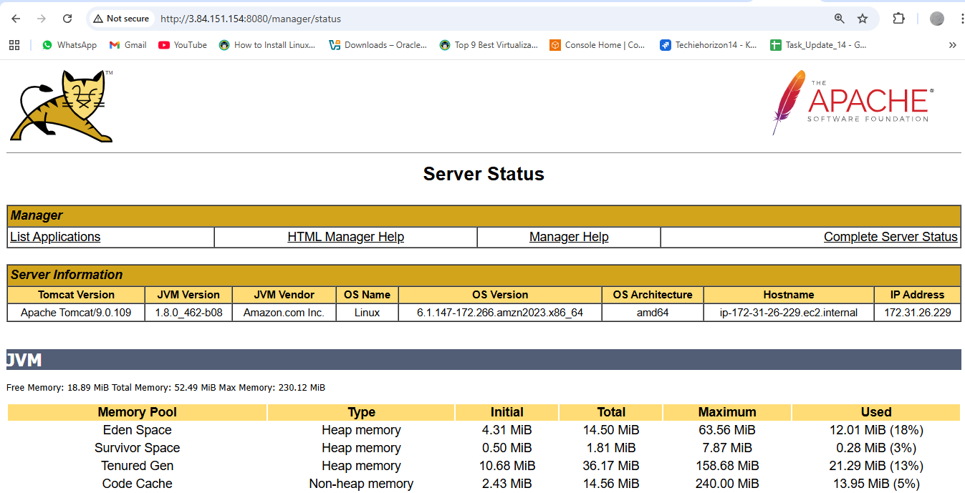
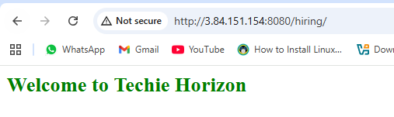
4) Create one parallel stage pipeline job
Login to Jenkins
- Open Jenkins (http://<jenkins-server>:8080) and log in.
Create a New Pipeline Job
- Click New Item.
- Enter a name (e.g., Parallel-Pipeline).
- Select Pipeline and click OK.
Configure the Pipeline
- Scroll to the Pipeline section.
- Choose one of these:
  - Pipeline script → Paste your pipeline code directly.
  - Pipeline script from SCM → Fetch pipeline code (Jenkinsfile) from Git.
Define Parallel Stages
- Inside your pipeline, add a parallel {} block under a stage.
- Each branch inside parallel {} runs at the same time.
Save and Build
- Click Save.
- Click Build Now.

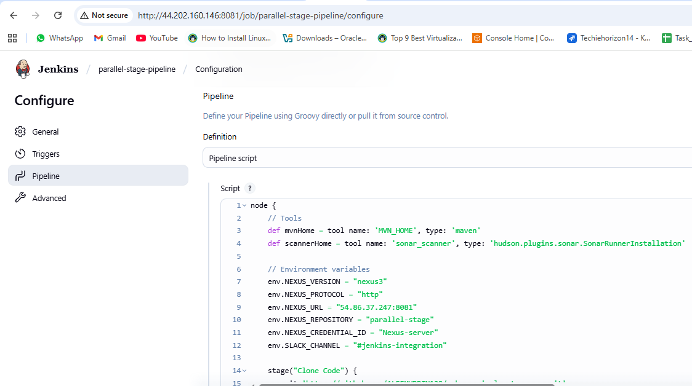
node {
// Tools
def mvnHome = tool name: 'MVN_HOME', type: 'maven'
def scannerHome = tool name: 'sonar_scanner', type: 'hudson.plugins.sonar.SonarRunnerInstallation'

// Environment variables
env.NEXUS_VERSION = "nexus3"
env.NEXUS_PROTOCOL = "http"
env.NEXUS_URL = "54.86.37.247:8081"
env.NEXUS_REPOSITORY = "parallel-stage"
env.NEXUS_CREDENTIAL_ID = "Nexus-server"
env.SLACK_CHANNEL = "#jenkins-integration"

stage("Clone Code") {
git 'https://github.com/ALEEMUDDIN138/sabear_simplecutomerapp.git'
}

stage("Build") {
sh "${mvnHome}/bin/mvn -Dmaven.test.failure.ignore=true clean install"
}

stage("SonarCloud") {
withSonarQubeEnv('sonarqube_server') {
sh """
${scannerHome}/bin/sonar-scanner \
-Dsonar.projectKey=Ncodeit \
-Dsonar.projectName=Ncodeit \
-Dsonar.projectVersion=2.0 \
-Dsonar.sources=${WORKSPACE}/src/ \
-Dsonar.binaries=target/classes/com/visualpathit/account/controller/ \
-Dsonar.junit.reportsPath=target/surefire-reports \
-Dsonar.jacoco.reportPath=target/jacoco.exec \
-Dsonar.java.binaries=src/com/room/sample
"""
}
}

stage("Publish to Nexus") {
script {
def pom = readMavenPom file: "pom.xml"
def filesByGlob = findFiles(glob: "target/*.${pom.packaging}")
echo "${filesByGlob[0].name} ${filesByGlob[0].path}"
def artifactPath = filesByGlob[0].path
def artifactExists = fileExists artifactPath
if (artifactExists) {
nexusArtifactUploader(
nexusVersion: env.NEXUS_VERSION,
protocol: env.NEXUS_PROTOCOL,
nexusUrl: env.NEXUS_URL,
groupId: pom.groupId,
version: pom.version,
repository: env.NEXUS_REPOSITORY,
credentialsId: env.NEXUS_CREDENTIAL_ID,
artifacts: [
[artifactId: pom.artifactId, classifier: '', file: artifactPath, type: pom.packaging],
[artifactId: pom.artifactId, classifier: '', file: "pom.xml", type: "pom"]
]
)
} else {
error "*** File: ${artifactPath}, could not be found"
}
}
}

stage("Deploy to Tomcat") {
withCredentials([usernamePassword(credentialsId: '6032f458-5f14-4354-9500-645db052e2b5', usernameVariable: 'TOMCAT_USER', passwordVariable: 'TOMCAT_PASS')]) {
script {
def warFile = sh(script: "ls target/*.war | head -n 1", returnStdout: true).trim()
echo "Renaming WAR to simplecustomerapp.war ..."
sh "cp ${warFile} target/simplecustomerapp.war"

echo "Deploying simplecustomerapp.war to Tomcat at context path /simplecustomerapp ..."
sh """
curl -u $TOMCAT_USER:$TOMCAT_PASS \
-T target/simplecustomerapp.war \
"http://3.84.151.154:8080/manager/text/deploy?path=/simplecustomerapp&update=true"
"""
}
}
}

stage("Slack Notification") {
slackSend(
channel: "${env.SLACK_CHANNEL}",
color: "#36A64F",
message: "Scripted pipeline for *Simple Customer App* has been successfully deployed in Tomcat :white_check_mark: by Aleem for Job: ${env.JOB_NAME} [${env.BUILD_NUMBER}]"
)
}
}
